**CODE**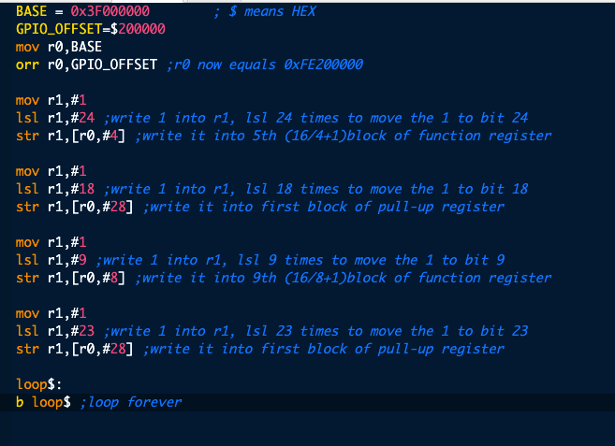

**EVIDENCE**

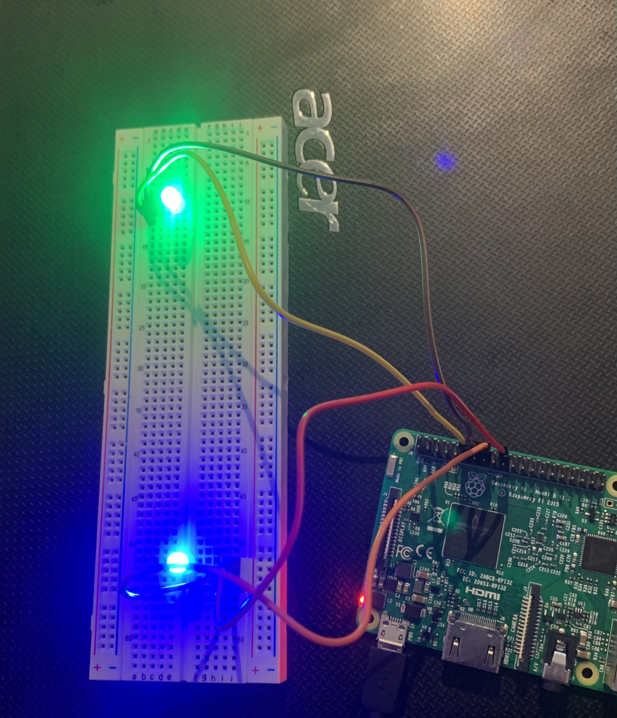

16.1. 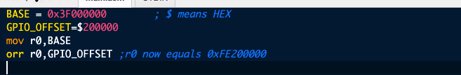

16.2.

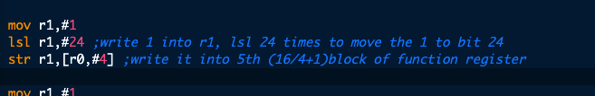

16.3.

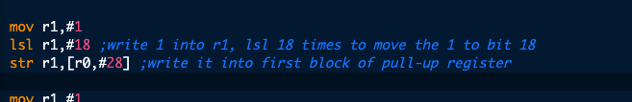

16.4.



19.1

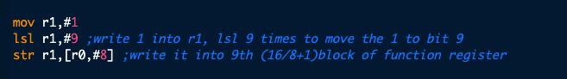

19.2.

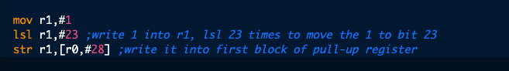

20.1. 9-bit

20.2 8

20.3 23

20.4 28

22.1

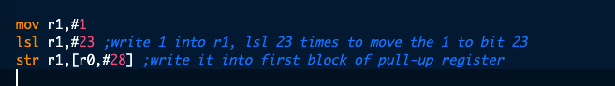

22.2

